*Assignment 3-4*

*Instructor: Faisal Khan*

|  |  |  |
| --- | --- | --- |
| *Name* | *Student ID* | *Group#* |
| *Vikas* | *C0753356* |  |
| *Ramanpreet Kaur* | *C0753270* |  |
| *Gurpreet Kaur Maan* | *C0753139* |  |
| *Jasbeer Kaur* | *C0752477* |  |

1-Use Documentation Comments where needed and use Javadoc to create HTML files for documentation.

2-In your project src folder add this word document with all your group members names and paste the screen shots of your output after each question.

3-Right Click on your Project Folder in Eclipse, Copy Option is available. Create a copy of the Project and upload the zipped folder using Moodle.

Create a web based application using JSPs & Servlets

With Controller Servlet and BootStrap library, based on MVC design pattern. Your web application should maintain

A Shipping Company Client Records. You can use a model class Clients with fields like.

ClientID,Name,Contact,ItemShipped,Date_Recived,Date_Shipped.You should be able to perform all these CRUD Operations.

a)Create a Database ShippingRecords for your application.

Create a table named clients in this database.

Insert 5 to 6 Records in this table.

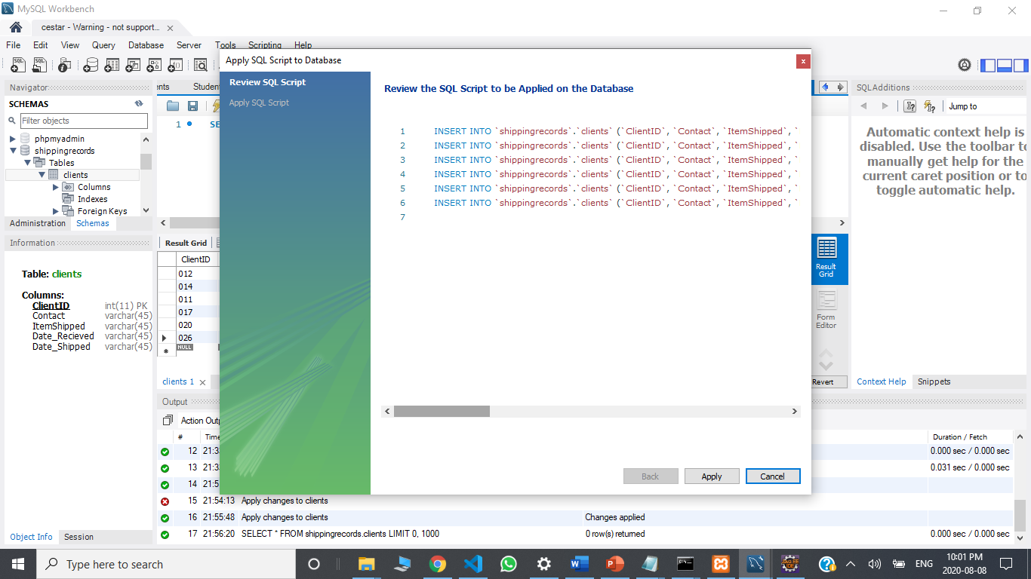

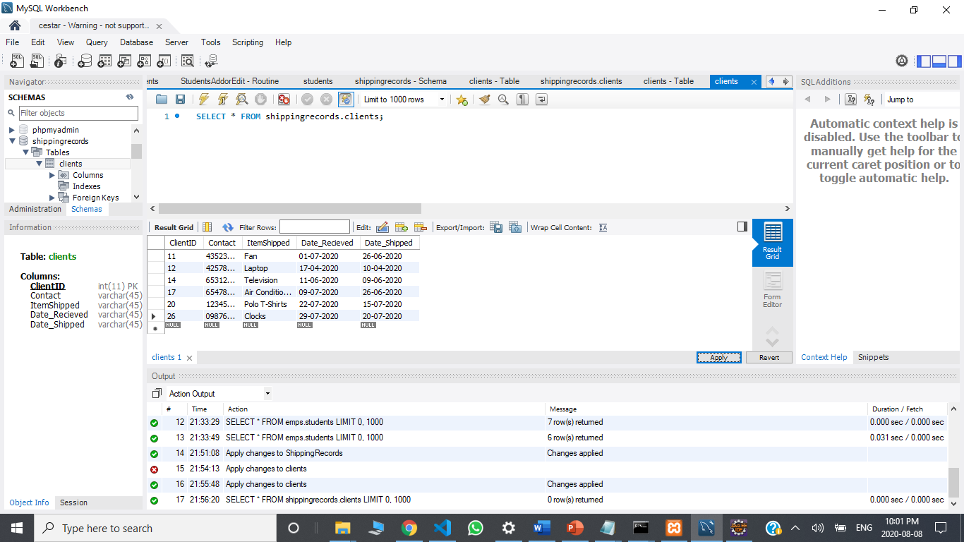

b) Display all the Clients Record in your JSP page View as a table.

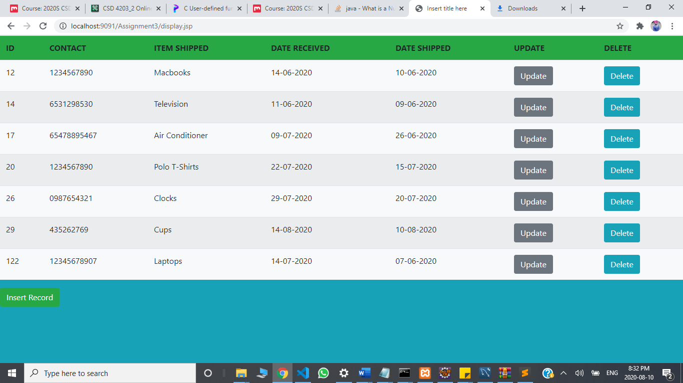 20

c) Add a new Client Record in to the database using a button on your view page. 20

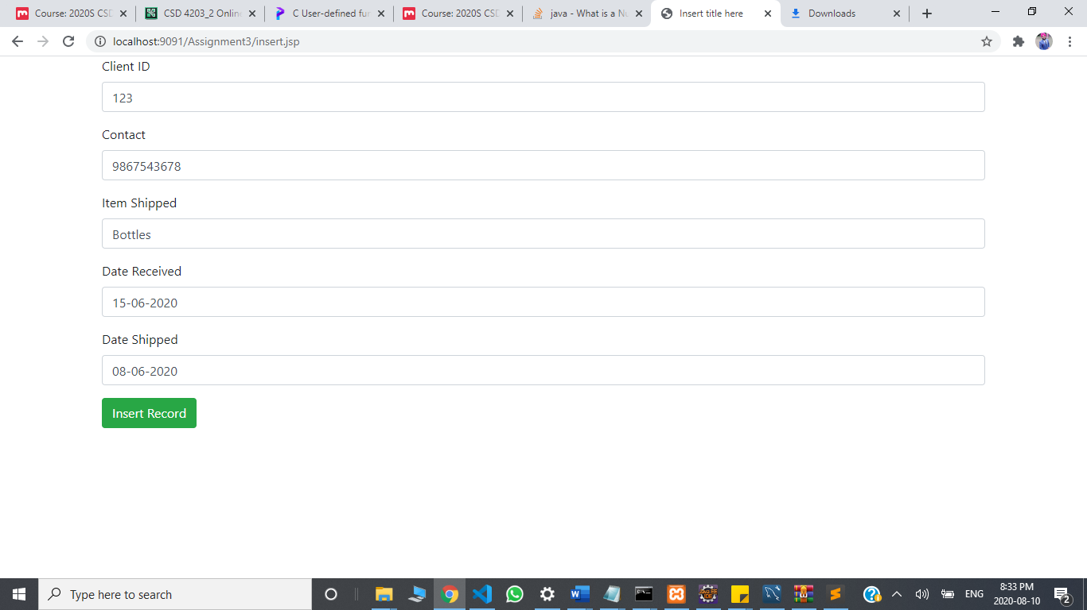

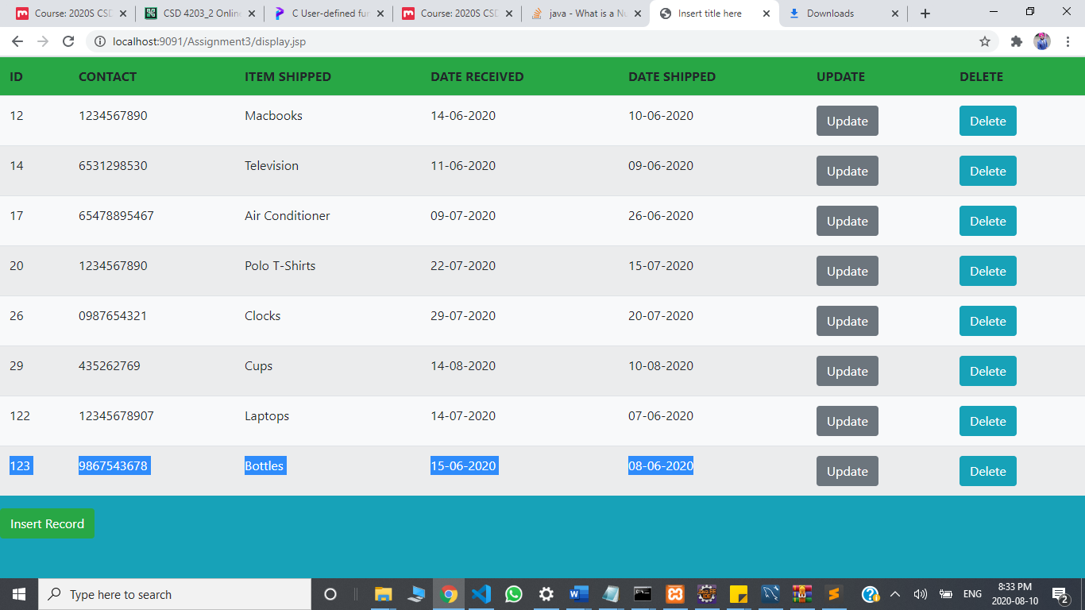

d)Delete a Client Record using a Delete button on your view page. 20

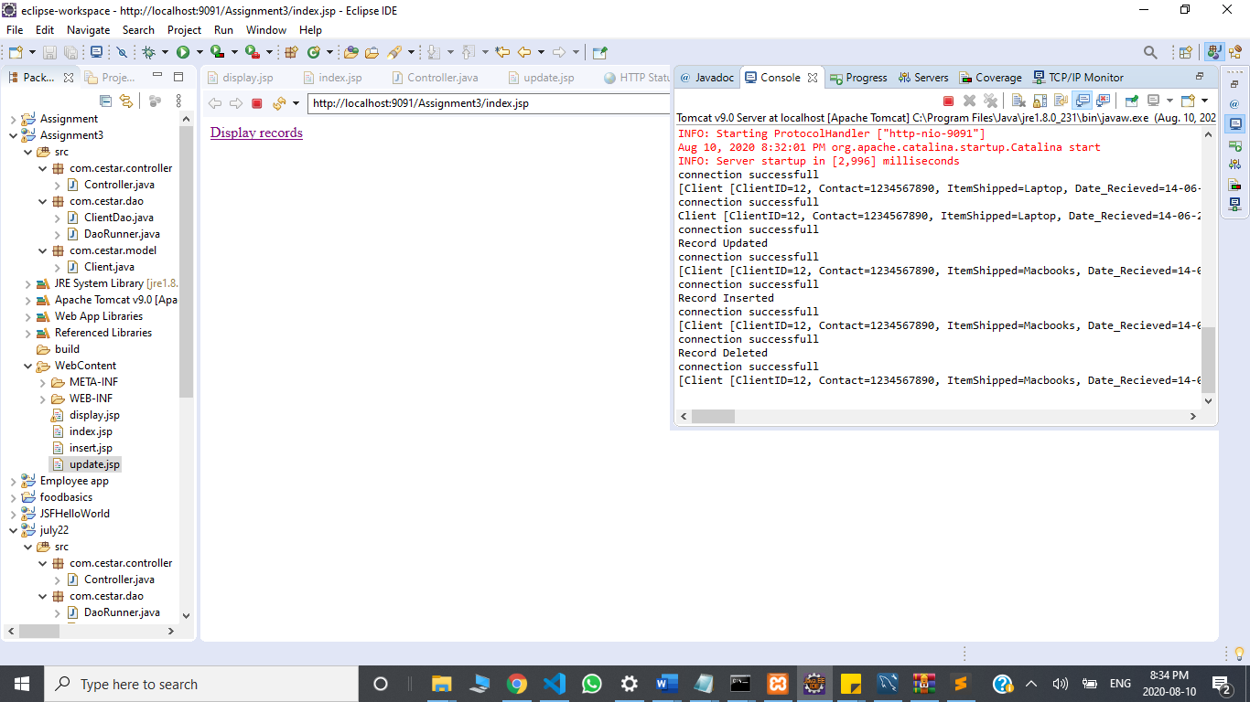

e) Use BootStrap Library and create separate DAO class for Crud operations.Try to create separate methods for all crud operations. 30

